🚀 Vyor Core AI Engine
This repository contains the core low-latency Architecture implementing adaptive long-term memory management, real-time dynamic routing, and automated evaluation interfaces.

📌 Core Architecture Workflow
The system is designed as a modular pipeline where data flows through specialized neural gates and analytical loops:
[Incoming Context/Queries]
│
▼
┌──────────────────────────────────┐
│ Titans Memory Core │ ──► Man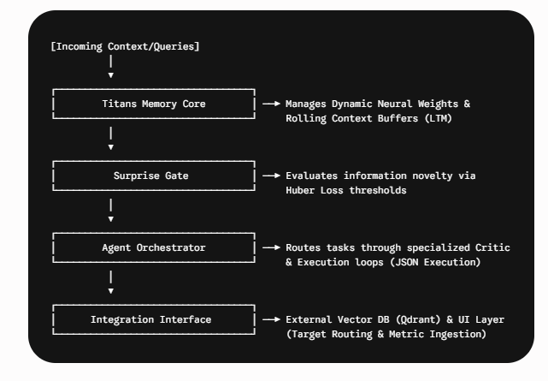ages Dynamic Neural Weights &

Components Breakdown
- titans_memory.py: Handles Long-Term Memory (LTM) mechanics, tracking token semantics and maintaining context over extended sessions.
- surprise_gate.py: A mathematical filter utilizing surprise tracking (Huber Loss computation) to dynamically handle high-novelty data bursts.
- orchestrator.py: The multi-agent coordinator that manages execution states, runs iterative reasoning loops, and ensures output syntax formatting.
- integration_interface.py: The central gateway built to bind the core architecture with external infrastructure layers, handling vector stream queries and UI-bound metadata payloads.
- test_pipeline.py: End-to-end integration script to validate state management and routing matrices under extreme test scenarios.

⚡ Integration & Next Steps
To test the end-to-end capabilities against target benchmark datasets (EnterpriseRAG-Bench / BABILong):
- Database Binding: Connect the live Qdrant client instance to the retrieval hooks exposed inside integration_interface.py.
- UI Stream Integration: Route the structured JSON outputs from the orchestrator directly into the frontend interface components.
- Execution: Run the master test pipeline to verify matrix scoring and latency benchmarks:
Bash
python test_pipeline.py

